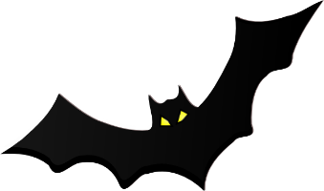
B.A.T. Review
Cells

________________________________
NAME:
_____________
PERIOD

VOCABULARY
- Turgor Pressure
- Synthesis
- Solvent
- Solute
- Passive Transport
- Active Transport
- Osmosis
- Diffusion
- Facilitated Diffusion
- Hypotonic
- Hypertonic
- Isotonic
- Equilibrium
- Concentration Gradient
- ATP

Endocytosis – Active Transport taking molecule(s) into a cell
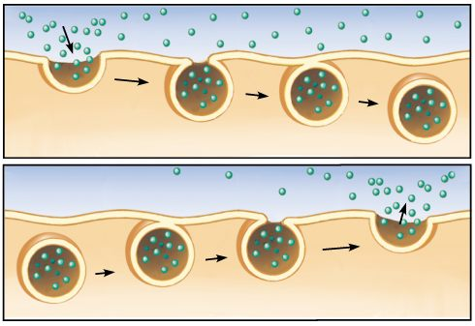
Exocytosis – Active Transport moving molecule(s) out of a cell

CELLULAR MEMBRANE
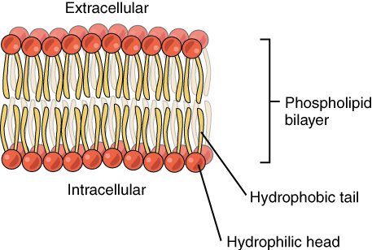
- Is Semi-Permeable (it only lets certain molecules through the membrane)
- Maintains Homeostasis (internal balance. Ex body temp.)
- Helps with structure and support along with eliminating waste and taking in food for the cell.
- Is made up of a LIPID BILAYER and PROTEINS

CELLULAR TRANSPORT TYPES

2 Types of Cellular Transport
PASSIVE TRANSPORT
ACTIVE TRANSPORT

- Energy Required called ATP
- Molecule Movement From LOW to HIGH concentration
- Goes AGAINST the concentration gradient
- Endocytosis – into a cell
- Exocytosis – out of a cell
- No Energy Required
- Molecule Movement From HIGH to LOW concentration
- Goes WITH the concentration gradient

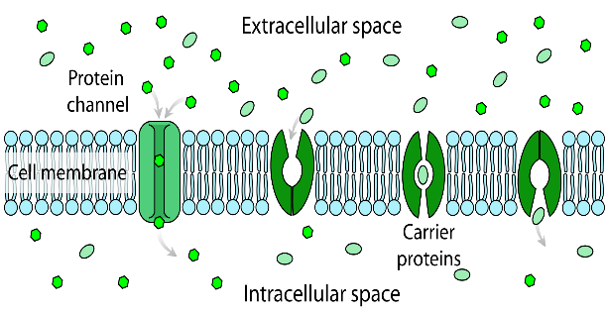
THREE TYPES OF PASSIVE TRANPORT
- Diffusion (O₂, CO₂, anything!)
- Osmosis
Diffusion only for water
- Facilitated Diffusion
Diffusion with protein channels to help move molecules across the membrane

Plasmolysis/Crenate
SOLUTION TYPES
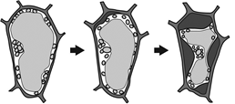
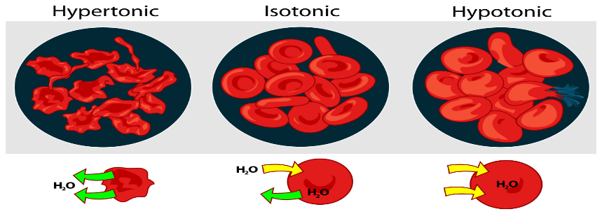

EQUAL amount of Solute on both sides of cell
MORE Solute on the outside of cell
LESS Solute on the outside of cell
No mass Change
Decrease in mass
Cell will decrease in mass
Water moves in direction of more solute (solute sucks).

MORE Solute on the outside of cell. What will happen?

Increase in mass

CELL TYPES
VIRUSES
LIVING
Ribosomes
Cell Walls
Cytoplasm
Biomolecules

Made of at least one Cell
Not Considered Living
Do not classify as a Eukaryotic or a Prokaryotic Cell

Virus Structures
Look Like:

EUKARYOTIC CELLS
One to Many Celled Organisms
********NUCLEUS*******
HAS MEMBRANE-BOUND ORGANELLES

Animals
Plants
PROKARYOTIC CELLS
Only One Celled Organism
***NO NUCLEUS***
NO MEMBRANE-BOUND ORGANELLES

Bacteria

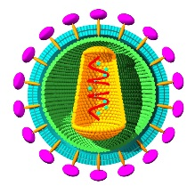
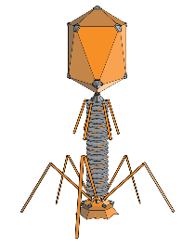

Protists & Fungus
PROTEINS
PACKAGE IT
MAKE IT
DELIVER IT
GOLGI
RIBOSOMES
ER
ENERGY FOR CELLS
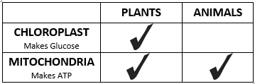

BIOMOLECULES
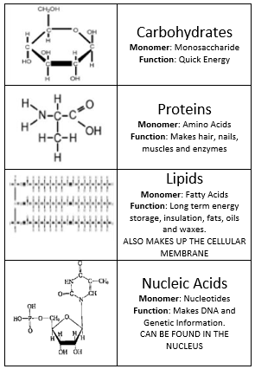
PARAMECIUM ORGANISM
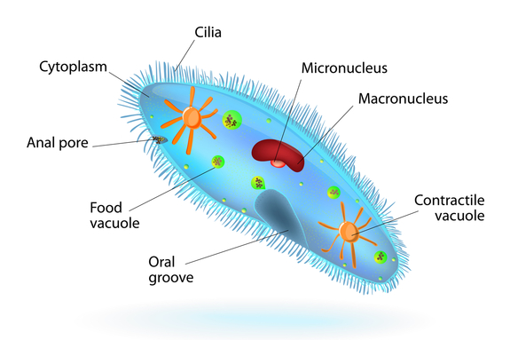

Paramecium Organisms live in the water. They are considered one of the few single celled Eukaryotic organisms. It contains two nucleuses (Nuclei). One big one and one small one.
Endosymbiont Theory
How Eukaryotic cells arose
Mitochondria and Chloroplasts are evidence because they:
- Have ribosomes similar to prokaryotes
- Have their own circular DNA like prokaryotes
- Reproduce by binary fission like prokaryotes

NAME: _____________________________________ PERIOD: _______
B.A.T. Review Questions

- What type of solution causes a cell to expand? __________________
- What type of solution causes a cell to shrink? ___________________
- What types of solution causes a cell to be in a homeostatic state (meaning no change)? ________________
- (Circle one) In a HYPOTONIC solution the solute is MORE / LESS / EQUAL concentrated in the cell.
- (Circle one) In a HYPERTONIC solution the solute is MORE / LESS / EQUAL concentrated in the cell.
- What happens to the cell if it places in a hypotonic solution? __________________________.
- What happens to the cell if it places in a hypertonic solution? __________________________.
- The cell structure that allows substances in and out of the cell. __________________________.
- What two biomolecules makes up majority of the cellular membrane? __________________________.
- What does Semi-Permeable mean? _____________________________________________________________
- How does a cell’s membrane help the cell to survive? ______________________________________________ ___________________________________________________________________________________________
- Describe the structure and alignment of the phospholipids in the cell membrane. ______________________ _________________________________________________________________________________________ ________________________________________________________________________________________
- What three structures are involved in protein synthesis and delivery? _______________________________ _________________________________________
- What are proteins made of? _________________________________________________
- What two cell structures eliminate waste? _____________________________________________________
- The two types of cellular transport are ______________________ and _______________________.
- ____________________ transport requires energy and _________________________ does not require energy to move molecules through the cell’s membrane.
- The three types of passive transport are ______________________, ______________________ and ______________________.
- ______________________ is only to describe diffusion for water.
- Facilitated Diffusion needs the help of _______________________________ to help push molecules through the cellular membrane.
- Active Transport requires what type of energy? ___________________
- Passive transport are when molecules moving from ___________ to ___________ concentration.
- Active transport are when molecules moving from ___________ to ___________ concentration.
- Name the structure that is embedded into the cellular membrane in the diagram. ______________________

- (Circle one) Passive Transport goes WITH / AGAINST the concentration gradient while active transport WITH / AGAINST the concentration gradient.

- What kind of organisms are prokaryotic cells?
- What kind of organisms are eukaryotic cells?
- What are 3 structures found in plant cells but not in animal cells? _____________________________________ ______________________________________________________________________________________________________________________________________________________________________________________
- What macromolecule is found in cell walls of plants? _____________________________
- ____________________ cells have a nucleus while _________________ do not have a nucleus.
- What type of cells have membrane-bound organelles? ___________________________
- Explain what similarities all Eukaryotic cells have in common? ______________________________________________________________________________________________________________________________________________________________________________________

- Viruses are considered __________________ and only share the characteristic of having __________________ inside them with cells.

- What type of energy is produced by a mitochondria? __________________
- What types of energy is produced by a chloroplast? __________________
- Animals have MITOCHONDRIA / CHOLORPLAST / BOTH organelles to give them energy.
- Plants have MITOCHONDRIA / CHOLORPLAST / BOTH organelles to give them energy.

- Proteins are made by __________________ shipped by __________________ and packaged by __________________.
- Do both cell types have ribosomes? ______ Why? ______________________________________________

- Are paramecium single or multi-celled? __________________
- What type of cell do paramecium classify as? __________________. Do they have a nucleus? __________
- Would paramecium be effected if you placed them in a hypotonic or hypertonic solution? __________________

- What type of cell do Euglena classify as? __________________
- Would Euglena be effected if you placed them in a hypotonic or hypertonic solution? __________________
- Do they have a nucleus? __________________

- What does the Endosymbiont Theory explain? _______________________________________________________
- What 3 things do mitochondria and chloroplasts have in common with prokaryotes? __________________________ _______________________________________________________________________________________________

