**STAAR Review**

**Category 1: Biochemistry & Cells**

**Background Information: Organic Compounds, Cells & Viruses**

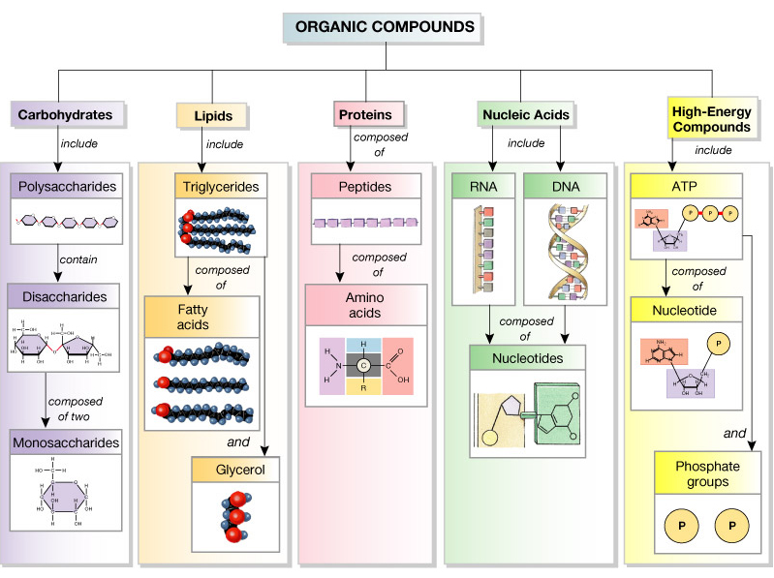



**Organic compounds usually come from living organisms. They contain Carbon along with Hydrogen and Oxygen. They are polymers made up of smaller subunits called monomers.**

**Carbohydrates**:

1. Elements- CHO (carbon, hydrogen & oxygen)

2. Monomer (building block- saccharides (sugars)

3. Function- quick energy & structure

4. ex’s- glucose, sucrose (table sugar), starch & glycogen

5. structure = rings

**Lipids**:

1. Elements- CHO

2. Monomer- 3 fatty acids & glycerol

3. Function- fat & oil give long term energy, cholesterol and phospholipid for cell membranes

4. ex’s- fats, oils, waxes, steroids, phospholipids 5. Structure = chains, E

**Proteins**:

1. Elements- CHON

2. Monomer- amino acids (20)

3. Function- structural, enzymes speed up reactions

**Nucleic Acids**:

1. Elements- CHONP

2. Monomer- nucleotide (sugar, phosphate & a base- A, T, C & G)

3. Function- store & transmit hereditary information

4. ex’s- DNA, RNA

4. ex’s- collagen & hemoglobin, hormones

5. structure = (R group)

 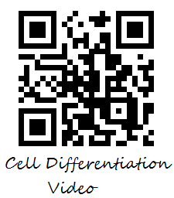



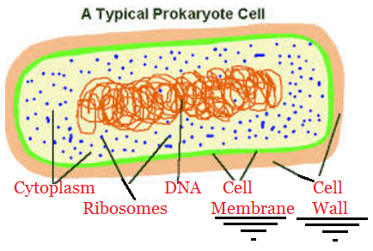

**Cells**:

**- Prokaryotes** (ONLY bacteria): lack a nucleus, have ribosomes, cell membrane, cell wall

**- Eukaryotes** (everything else: including protists, fungi, plants & animals): have a nucleus & many organelles

**- Plant cells**: have a vacuole (store water) chloroplasts (carry out photosynthesis), and a cell wall made of cellulose

**- Animal cells**: centrioles (for division), NO CELL WALL, NO CHLOROPLASTS!

**- ALL CELLS**: have a cell membrane, cytoplasm, genetic material (DNA or RNA), and ribosomes (site of protein synthesis)

**Cell differentiation** is a regulated process allowing cells to develop specific shapes and functions during embryonic development. This leads to blood cells, nerve cells, bone cells, stomach cells, skin cells and more. Every cell has a complete copy of DNA but different sections of DNA are used in different cells. Cell expression is also affected by temperature (rabbits’ fur changing color in cold temperatures), available nutrients and other environmental factors.

**Specialized Cells:**

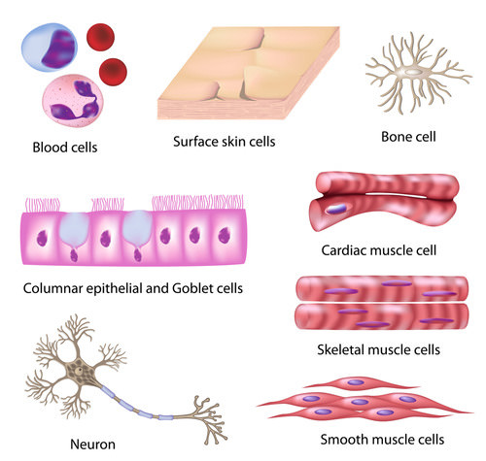 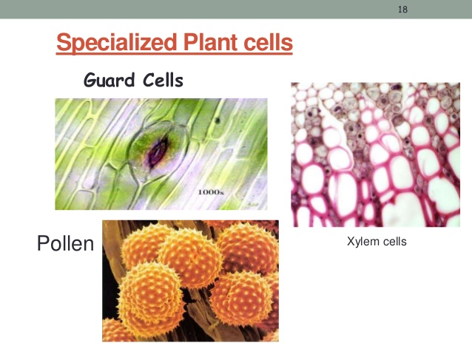

Cells that have developed special functions and features. An example in animals includes a red blood cell, which has no nucleus but contains hemoglobin to carry oxygen. An example in plants are the cells in the leaf contain chloroplast to carry out photosynthesis.

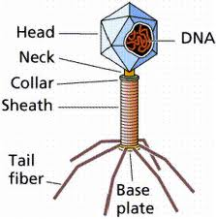

**Viruses**:

NOT LIVING - particles of nucleic acid (DNA or RNA) wrapped around a protein coat, and in some cases, a capsule made of lipids; NOT made of cells; cannot live independently outside of a host, all they do is replicate; a typical virus is composed of a core of DNA or RNA surrounded by a protein coat



Structure: capsid- a virus’s protein coat that helps virus enter host cell

**Bacteriophage**- virus that infects a bacterium

**Lytic Cycle Viral Infection-** viral replication cycle in which a virus takes over a host cell’s genetic material and uses the host cell’s structures and energy to replicate until the host cell bursts, killing it

**Lysogenic Cycle Viral Infection**- viral replication cycle in which a virus’s nucleic acid is integrated into a host cell’s chromosome; the host cell is not killed until the lytic cycle is activated

Virus attaches to cell, injects its nucleic acid and “tricks” the cell’s DNA into making viral DNA. In the lytic cycle the virus immediately replicates and invades more cells. In lysogenic cycle the virus waits to replicate while it gets copied through mitosis into more cells. After a time, it replicates in all cells at once.

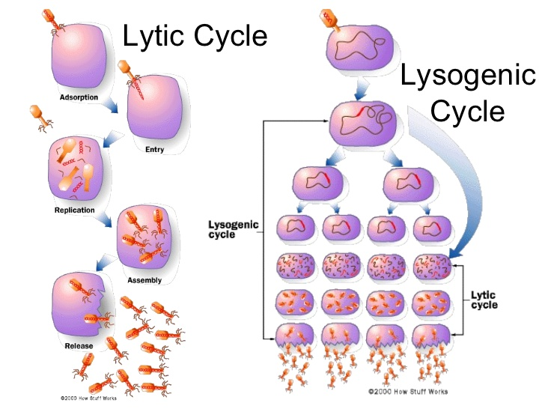

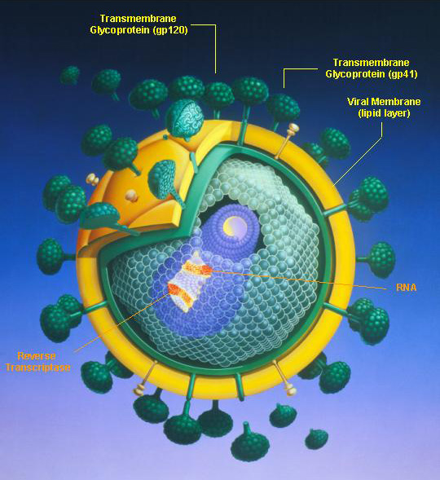

**Retroviruses:** Contain RNA as their nucleic acid (genetic information), instead of DNA

Called retroviruses because genetic information is copied backwards, from RNA to DNA

The DNA is then integrated into the host cell’s chromosome

Examples include: HIV, some cancers, hepatitis are caused by retroviruses

**HIV Virus:** Infects helper T cells in the immune system.

HIV can incubate for years, then it will be activated.

AIDS = acquired immunodeficiency syndrome, infected persons cannot fight off other diseases.

**BIOMOLECULE, CELLS, AND VIRUS QUESTIONS:**

 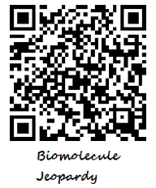 

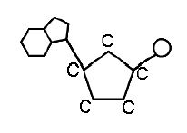

1. The diagram to the right is the **monomer** of **nucleic acids**. What is this monomer?

a. amino acid

b. saccharide

c. 3 fatty acids & glycerol

d. nucleotide

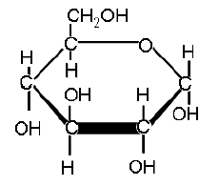

2. The diagram above represents which of the following **biomolecules**?

a. carbohydrate

b. protein

c. lipid

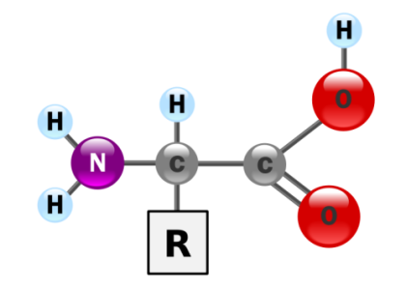 d. nucleic acid

3. The diagram to the right represents which of the following **biomolecules**?

a. carbohydrate

b. protein

c. lipid

d. nucleic acid

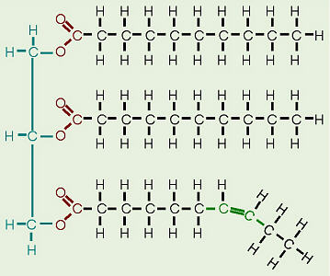

4. The diagram to the right represents which of the following **biomolecules**?

a. carbohydrate

b. protein

c. lipid

d. nucleic acid

**Specific biomolecules serve various functions in the body.**

5. Study the statement above. Identify the molecule, which is **broken down during respiration** forming water and carbon dioxide and releasing energy.

a. deoxyribonucleic acid (DNA)

b. glucose

c. nicotinamide adenine dinucleotide (NAD+)

d. hemoglobin

6. Study the statement above. Identify the molecule which **stores energy** in its chemical bonds for quick, easy use by cells.

a. nicotinamide adenine dinucleotide (NAD+)

b. glucose

c. hemoglobin

d. adenosine triphosphate (ATP)

**Four major groups of organic compounds are particularly important to living things. Most life processes rely on molecules from one or more of these groups.**

7. To which group do **sugars** belong?

a. nucleic acids b. proteins c. lipids d. carbohydrates

8. To which group do **RNA** molecules belong?

a. nucleic acids b. proteins c. lipids d. carbohydrates

9. To which group do enzymes belong?

a. lipids b. proteins c. carbohydrates d. nucleic acids

10. To which group do oils belong?

a. nucleic acids b. carbohydrates c. lipids d. proteins

11. Certain types of biomolecules are crucial to a variety of life processes and body structures. One of these types of molecules are **proteins**, which are-

a. composed of building blocks called amino acids

b. insoluble in water and are used by the body for energy storage and insulation

c. complex biomolecules that store genetic information

d. organic compounds used by cells to store and release energy

12. Which of these important chemicals forms the framework for **carbohydrates**, **fats**, and other molecules of life?

a. nitrogen b. oxygen c. water d. carbon

13. Like complex carbohydrates, proteins are biomolecules that serve many functions and can be chemically broken down and restructured. Both **proteins** and complex **carbohydrates** are which of the following?

a. polymers of smaller subunits

b. sequences of sugars

c. lipids of large molecules

d. nucleotides of DNA

14. Cell Differentiation results in developing embryos having different types of cells. Cell differentiation is regulated by

a. DNA b. lipids c. sugars d. enzymes

**Miguel is looking at cells through a microscope. His teacher, Mrs. Sheng, has told him that he is viewing either a tomato cell or a bacterial cell. Mrs. Sheng would like Miguel to answer some questions about the cell he is looking at.**

15. Read the information above. Mrs. Sheng asks Miguel to figure out what type of cell he is viewing. What cell **structure** should Miguel be looking for to determine whether this cell came from a **tomato plant or a bacterium**?

a. ribosomes b. mitochondria c. nucleus d. DNA

16. Many scientists classify viruses as non-living things. Which of these best describes why a virus might be classified as non-living?

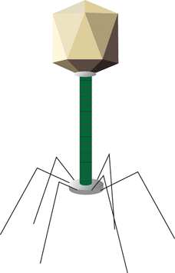

a. It has no genetic material of its own.

b. It reproduces only when it is inside a cell.

c. It can take control of a cell and change its normal activities.

d. Its effects on an organism are always harmful.

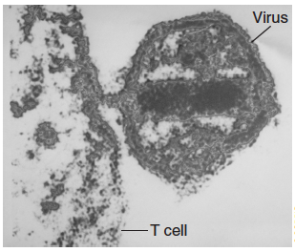

17. The photograph to the right shows a virus attacking a human T cell (immune cell).

Which disease could result if many **T cells are destroyed** in this manner?

a. AIDS

b. Tuberculosis

c. Chicken pox

d. Multiple sclerosis

18. A virus has been approved for use as a food additive because it attacks and kills bacteria harmful to humans. The **virus kills** the **bacteria** by doing which of the following?

a. ingesting the bacteria

b. injecting its own genetic material into the bacteria

c. absorbing the oxygen that the bacteria need for respiration

d. producing toxins that prevent the bacteria from reproducing

19. **Viruses** that cause an onset of symptoms within several days likely have this life cycle.

a. lytic

b. lysogenic

d. mitotic

d. meiotic

20. If a flu virus infects a person, which of the following will **MOST** likely occur inside the person?

a. Deformed bone and skin cells will appear

b. The pH of the bloodstream will change slightly

c. The number of viruses will increase dramatically

d. Body cells will temporarily stop undergoing mitosis

21. How does a **virus differ** from a **cell**?

a. Viruses are much larger than the largest cells

b. A virus cannot copy itself unless it is inside a living cell

c. Cells make people sick, but viruses heal them

d. A virus can make copies of itself before invading a body

22. Why do antibiotics not work on viral infections?

a. Antibiotics are used to increase the reproduction rate of viruses

b. Antibiotics can only kill living bacteria, they don’t affect nonliving viruses

c. Antibiotics must be taken prior to the viral infection to work

d. Antibiotics only kill animal cells

**STAAR Review**

**Category 1: Biochemistry & Cells *PART 2***

**Background Information**: **Cell Transport and Cell Cycle**

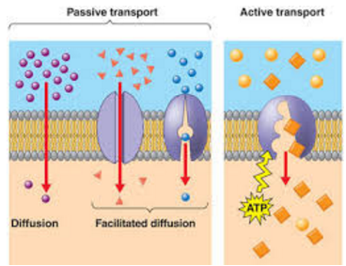

When molecules move from a high to low concentration it is called moving DOWN the concentration gradient. (Passive transport)  
When molecules move from a low to high concentration it is called moving AGAINST the concentration gradient.(Active transport)When the concentration of a solute is the same throughout a system, the system is at EQUILIBRIUM.

What kind of transport DOES NOT require energy? **PASSIVE**

What kind of transport requires energy? **ACTIVE**  
Which CELL PART provides the energy for active transport? MITOCHONDRIA  
Which MOLECULE is produced by mitochondria and provides energy for transport? **ATP**

Movement of molecules FROM a region of HIGH concentration TO a region of LOW concentration (WITH the concentration gradient) = **DIFFUSION**   
The movement of molecules FROM a region of HIGH concentration TO a region of LOW concentration with the HELP of carrier proteins or channels = **FACILITATED DIFFUSION**

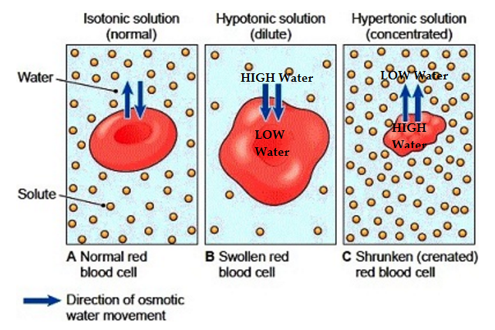

Membrane structures that move molecules across membranes by attaching, changing shape, and flipping to the other side like a revolving door or providing a tunnel = PROTEINS

The movement of WATER molecules from HIGH concentration to LOW concentration across a cell membrane = **OSMOSIS**

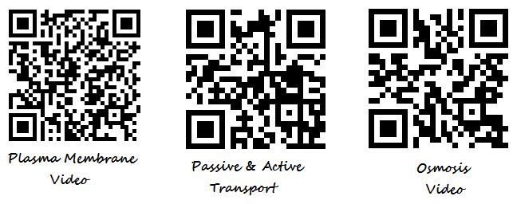

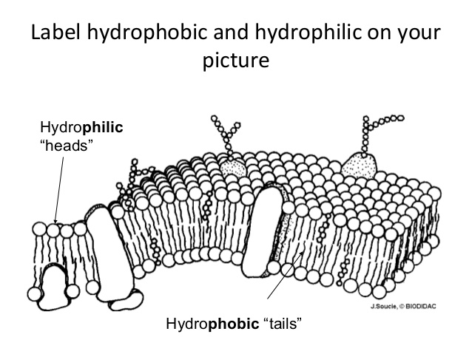

Cell Membrane AKA Plasma Membrane

**Cell organelles**:

**Mitochondria** “powerhouse”- makes energy needed for Active Transport

**Golgi body**- sorts and packages proteins (think of UPS)

**Nucleus**- brain/control center of the cell; instructions for making proteins

**Ribosome**- site of protein synthesis (think of meat-has protein in it)

**Endoplasmic Reticulum** – transports proteins

**Cell membrane**- controls what enter and leaves the cell, “semi or selectively permeable” (like a bouncer), made of two layers of phospholipids embedded with proteins. Semi-permeable. Responsible for maintaining homeostasis.

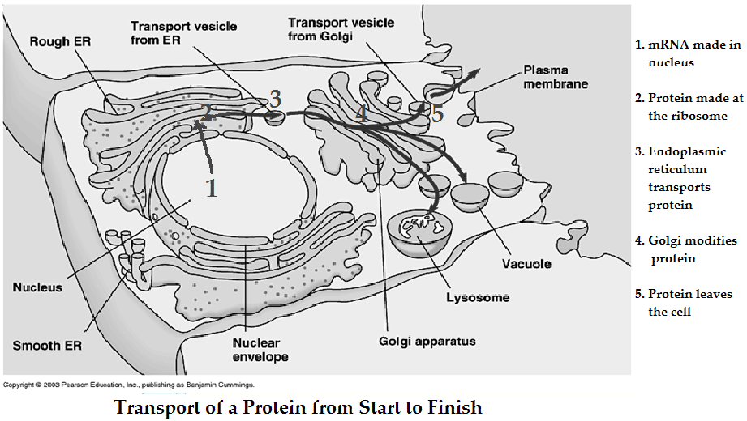

**Cell Cycle: Interphase + Mitosis (IPMAT)**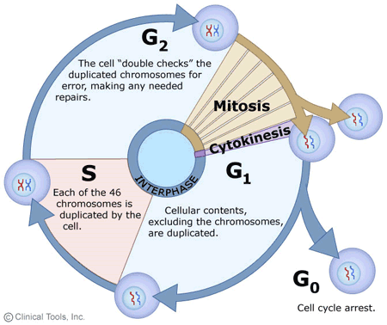

There are three phases of the cell cycle

1. Interphase
   1. G1 – normal growth and function; duplicates organelles
   2. S – DNA is replicated
   3. G2 – prepares for division; makes proteins; duplicates organelles
2. Mitosis or M phase
   1. Prophase, Metaphase, Anaphase, Telophase
   2. Nuclear division
3. Cytokinesis
   1. Cytoplasm splitting

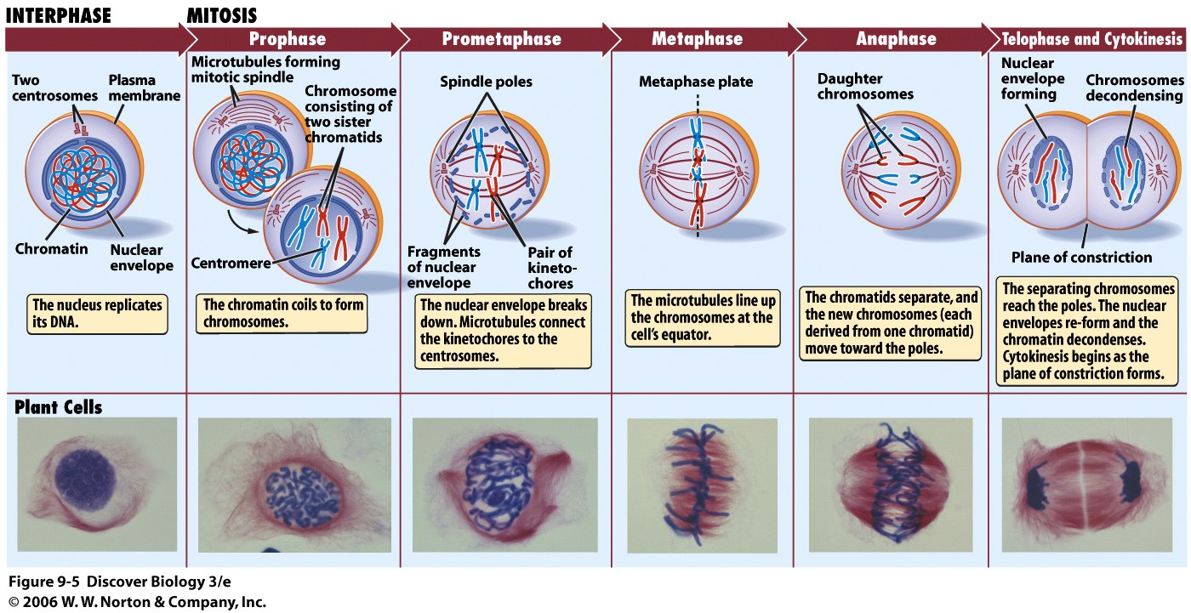

**Mitosis**: produces 2 genetically identical, diploid body (somatic) cells

**Diploid**: full set of chromosomes

In “my toes, nose & elbows” – body/somatic cells reproducing for growth and replacement.

**Meiosis**: produces 4 genetically different, haploid sex (gametes) cells

**Haploid**: chromosome # is half

In “my ovaries & testes” – cells in reproductive organs making

reproductive cells/gametes

**Crossing over** occurs during Prophase 1 to exchange traits

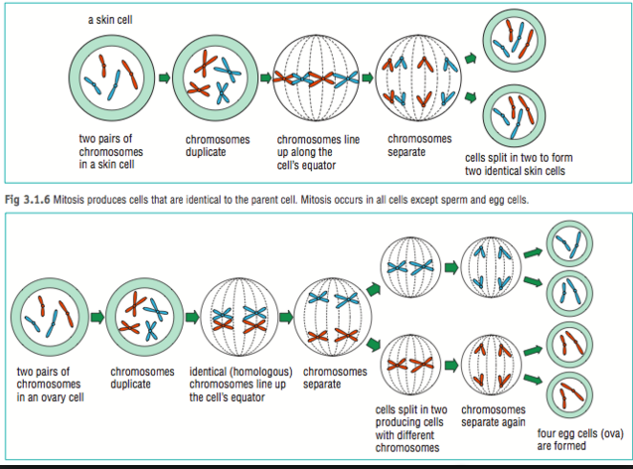

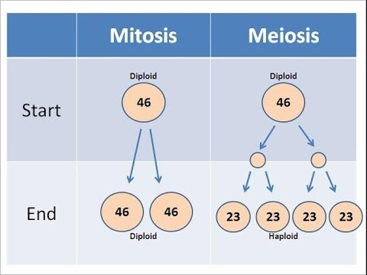

**Cancer**: Uncontrolled cell growth (no “resting” stage)

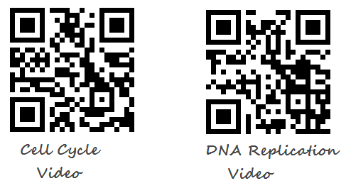

**Practice Questions:**

  

**Cell organelles carry out specific metabolic processes.**

1. Which cell organelle manages the process by which **proteins are sorted and packaged** to be **sent** where they are needed?

a. ribosomes b. lysosomes c. Golgi bodies d. vacuoles

2. Which cell organelle manages the process by which **proteins are assembled** based on DNA instructions?

a. mitochondria b. lysosomes c. ribosomes d. vacuoles

3. Which cell organelle manages the process by which **energy stored in food molecules** is **transformed into usable energy** for the cell?

a. lysosomes b. Golgi bodies c. mitochondria d. ribosomes

4. Which cell organelle below is NOT involved in production of new moleucules within a cell?

a. ribosomes b. cell membrane c. endoplasmic reticulum d. Golgi bodies

5. Why is energy needed for active transport?

a. molecules are moving against the concentration gradient.

b. molecules are negatively and positively charged

c. molecules become trapped inside the cell membrane.

d. molecules are moving with the concentration gradient.

6. During which stage of the cell cycle is DNA replicated?

a. Gap 1

b. S phase

c. Prophase

d. Mitosis

7. Which of these is ***not*** an advantage gained by organisms which **reproduce sexually**?

a. Genetic recombination created genetic diversity within a species.

b. Some percentage of organisms within a species will be likely to survive and reproduce despite harsh environmental conditions.

c. Genetic diversity reduces the risk of species extinction caused by hard environmental conditions.

d. Genetic diversity weakens a species’ overall ability to survive harsh environmental conditions.

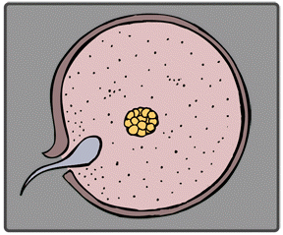8. A **fertilized egg** created through **sexual reproduction**-

a. has a combination of genetic material that is unique in the species

b. is genetically identical to other eggs of the same parents

c. is genetically identical to the parents

d. contains genetic material from only one parent

9. Which of the following statements about **sexual reproduction** is **false**?

a. Organisms that reproduce sexually produce sex cells called gametes.

b. Fertilization is part of the sexual reproduction process.

c. In sexual reproduction, a single parent produces identical offspring.

d. A zygote is produced through sexual reproduction.

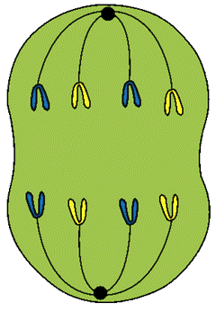**Michelle is looking through a microscope at a cell from an onion root. She sees a cell that is in the process of dividing to make a new cell. This is what Michelle sees:**

10. Study the diagram and the description above. If Michelle were able to find an **onion cell** that had **completed division**, what **products of cell division** would she see?

a. four different cells b. only one cell c. two identical cells d. four identical cells

11. Study the diagram and the statement above. Michelle is observing cell division in an onion cell, but this type of cell division also occurs in the human body. Which statement is ***not true*** about this type of **cell division in humans**?

a. This type of cell division is humans produces sex cells as well as body cells.

b. This type of cell division in humans occurs while bones are forming during development.

c. This type of cell division in humans can be affected by viruses.

d. This type of cell division in humans is necessary to heal cuts and wounds

12. Study the diagram and the description above. What is the name for the **process** Michelle is observing?

a. mutation b. meiosis c. mitosis d. metamorphosis

13. Study the diagram and the information above. Which of these statements about **cell division** is ***true***?

a. A newly formed daughter cell has less DNA than its parent cell.

b. Cells divide at random times.

c. New cells formed by cell division can replace dying cells in an organism.

d. The phases of cell division can occur in any order.

14. A special type of cell division, called **meiosis**, is used to form **sex cells or gametes**. Which statement is ***true*** about this type of **cell division**?

a. The products of meiosis are two identical cells.

b. DNA is not copied at all during meiosis.

c. The new cells have half the DNA of the parent cell.

d. Meiosis is complete after only one round of cell division.

15. A person with swollen gums rinses his mouth with **warm salt water**, and the **swelling decreases**. Which has occurred?

a. The swollen gums have absorbed the saltwater solution.

b. The saltwater solution lowers the temperature of the water in the gums.

c. The salt in the solution has moved against the concentration gradient.

d. The water in the gums has moved from a high to a low concentration of water.

16. What ***advantage*** do **sexually reproducing** organisms have over asexually reproducing organisms?

a. genetic variation b. genetic stability c. increased fertilization rate d. increased reproductive rate

17. What is the **most likely function** of a group of cells that contain a **high number of chloroplasts**?

a. respiration b. transpiration c. fermentation d. photosynthesis

18. In humans, **glucose** is kept ***in balance*** in the bloodstream by **insulin**. Which concept does this best illustrate?

a. adaptation b. homeostasis c. metabolism d. organization

* Meiosis, DNA & RNA, Protein Synthesis, Cellular Respiration & Photosynthesis covered in Categories 2 and 4