**STAAR REVIEW**

**Category 5: Environmental Systems**

**Background Information: Succession**

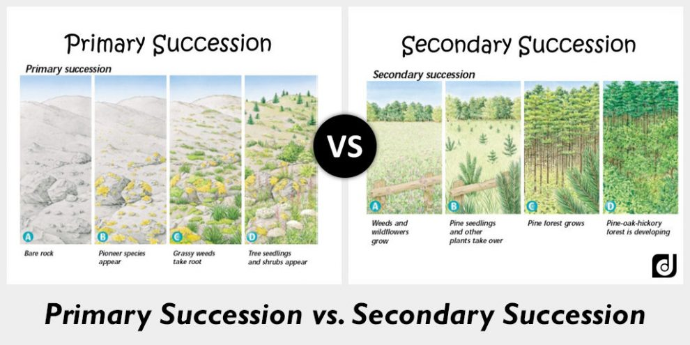

* The way a community comes into being is called ecological succession.
* It begins in a barren area (volcanic island, glacier retreat) where a pioneer species colonizes the region. These species reproduce and disperse well.
* Lichens are the main pioneer species. They can break down the minerals in rocks to begin to form soil. This process is called **primary succession. Primary succession starts from rocks (no top soil)**
* As soil forms from decomposition of earlier plants, small plants can grow. They die and their organic matter enriches the soil for larger plants to grow. Eventually larger and larger species can inhabit that area.
* **Secondary succession**—occurs in a disturbed area where soil is already in place (e.g. after forest fire). Faster than primary.
* Communities continue to replace each other until the climax community is reached. The climax community is a stable group of plants and animals for the area. Does not always mean large trees (e.g. grasses in prairies, cacti in deserts)

**Background Information: Ecosystem stability**

* Change in the environment can affect the stability of an ecosystem in positive or negative ways.
* Humans can affect ecosystem stability by habitat destruction, introduction of nonnative species, and release of pollution.

Example: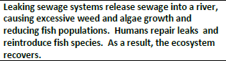

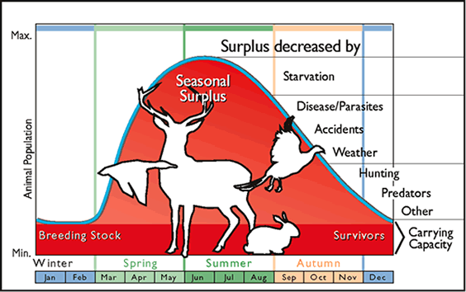

* The long term survival of organisms depends on the resources supplied by their environment. Resources necessary for the species to survive and reproduce include food, water, space, and mates. Within the environment, these resources are limited and availability can change over time. Without these resources the species may die or become extinct.
* Population size is influenced by – competition, predation, parasitism, disease, drought, climate extreme, human disturbances
* The maximum number of organisms an environment can support is called its **carrying capacity**

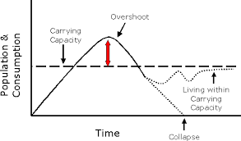

**Background Information: Flow of matter and energy**

Food Pyramid Food Web

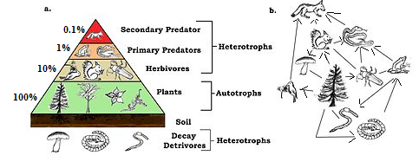

* Energy flows through an ecosystem one way: producers 🡪 primary consumer 🡪 secondary consumer 🡪 tertiary consumer (the arrows of a food chain/web show the flow of energy)
* A pyramid of energy shows the amount of energy available at each trophic level. Only 10% of the energy made/consumed is available for the next level. The other energy is used by the organism and given off as heat into the environment.
* **Carbon Cycle**
  + **The carbon cycle is a process that moves carbon between the atmosphere, the Earth’s surface, and living things. C**arbon is recycled through respiration, photosynthesis, fuel combustion, decomposition; carbon can be atmospheric or dissolved, or can be found in organic compounds within the body
    - In the atmosphere, carbon exists mostly as carbon dioxide. Carbon dioxide leaves the atmosphere when it dissolves in water or is taken up by plants for photosynthesis.
    - It is released in the atmosphere during cellular respiration, geologic processes such as volcanic eruptions, and when fossil fuels or forests are burned.
  + Consequences of disruption in carbon cycle
    - Over the past 100 years, the levels of carbon dioxide in Earth’s atmosphere have increased. Human activities such as the burning fossil fuels and forests are releasing carbon dioxide into the atmosphere at alarming rates and it is being released faster than it can be removed by natural processes.
    - Increasing levels of carbon dioxide is a major contributing factor to the global climate change. Scientists say that increasing carbon dioxide which is a greenhouse gas that helps keep heat from leaving the atmosphere. The higher carbon dioxide levels are causing rising temperatures and climate change.
    - The Greenhouse affect also affect the oceans. When CO2 or carbon dioxide dissolves in water, carbonic acid forms which causes the water to become more acidic (acidification). This negatively affects marine organisms that have a low tolerance for changing pH levels.
* **Nitrogen Cycle**
  + The nitrogen cycle involves the exchange of nitrogen between living things and their environment.
  + Nitrogen gas is removed from the atmosphere by a process called **nitrogen fixation**.
  + Nitrogen fixation is the process by which **BACTERIA** change nitrogen gas into a form that plants can use. Lightning can also fix nitrogen.
  + **BACTERIA** in the soil break down the remains of dead plants and animals, providing more fixed nitrogen to the soil. The actions of denitrifying bacteria return nitrogen to the atmosphere.
  + **Consequences of disruptions to the nitrogen cycle**
    - To increase plant growth, farmers and gardeners mix nitrogen containing fertilizer into the soil. The fertilizer runoff can affect the balance of nitrogen in bodies of water.
    - In a process called eutrophication, nitrogen dissolves in the body of water and stimulates the growth of plants and algae.
    - When plants and algae die, the bacterial populations that feed on dead matter boom. These bacteria consume so much oxygen from water that fish and other aquatic animals cannot survive.



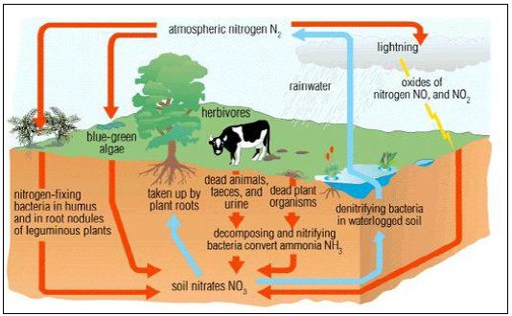

**Nitrogen Cycle**

**C**

**A**

**R**

**B**

**O**

**N**

**C**

**Y**

**C**

**L**

**E**

**Background Information: Relationships within ecosystem**

* **Symbiosis** is a relationship in which two different organisms have a close association with each other.
* **Mutualism** is a symbiotic relationship in which both organisms benefit. ☺ ☺
* **Commensalism** is a symbiotic relationship in which one organism benefits while the other organism is not affected in any way. ☺ 😐
* **Parasitism** is symbolic relationship in which one organism benefits while the other is harmed ☺ ☹

• **Predation** involves an organism known as a predator that eats part or all of another organism known as its prey.

• **Competition** occurs when two or more individuals or populations compete for the same resource, such as shelter or food

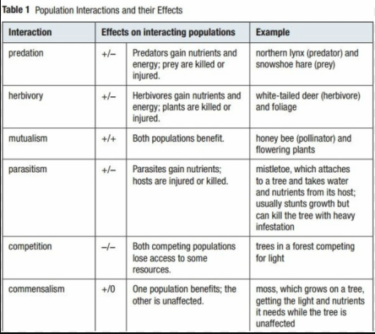

**Background Information: Role of microorganisms**

* Microorganisms can only be seen in a microscope. They play a critical role in the maintenance and disruption of the health of both individual organisms and entire ecosystems. Examples of microorganisms include bacteria, protists, yeast
* A **pathogen** is a virus, bacterium, or any organism that causes a disease.

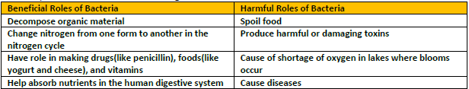

Name: __________________________________ Due Monday 5/1/17

**STAAR REVIEW**

**Category 5: Environmental Systems**

**1.** Microorganisms such as E. coli inhabit the digestive systems of a variety of higher organisms, including humans. These endosymbionts help their hosts maintain health by all of these EXCEPT

**A** breaking down food **B** producing key nutrients **C** infecting adjoining tissues **D** competing with harmful microorganisms

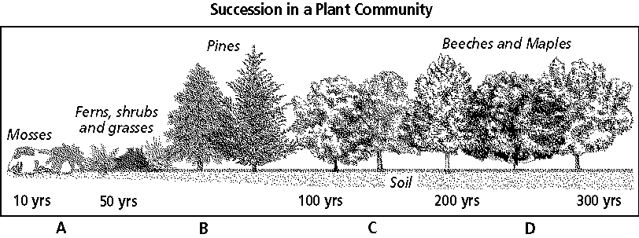

**2.** As the process of ecological succession progresses with time, species diversity tends to

**A** gradually decrease from colonization to climax community

**B** be limited in early stages and increase over time

**C** increase during intermediate stages, then rapidly decrease during the climax community stage

**D** be highest in the colonization stages

**3** Hummingbirds are attracted by large, brightly colored flowering plants. The flowers provide a food source for the hummingbirds in the form of nectar and in exchange, the hummingbirds transfer pollen from one flower to another. This relationship is best described as

**A** parasitism **B** mutualism **C** predation **D** commensalism

**4.** An herbicide is sprayed on foliage to eliminate weedy plants. This herbicide remains on the leaves of sprayed plants, is ingested by grasshoppers and accumulates in their tissues. Songbirds then feed on the grasshoppers and the herbicide accumulates in their tissues. Finally, the coyote feeds on songbirds and the herbicide accumulates in the coyote’s body. At which trophic level do the toxins become most concentrated?

**A** producers **B** primary consumers **C** secondary consumers **D** top consumers

**5.** Throughout the decade of the 1930’s, a series of severe dust storms blew across the prairie lands of the United States, causing extreme ecological and agricultural damage. Years of poor farming practices and drought resulted in the loss of tons of topsoil to prevailing winds. Millions of acres of land became barren and uninhabitable. Which is the best description of how this event likely impacted the natural prairie ecosystem that inhabited the area?

**A** Carrying capacity of the environment increased. **B** The mature prairie community was replaced with weedy species.

**C** Biodiversity increased. **D** Primary succession occurred.

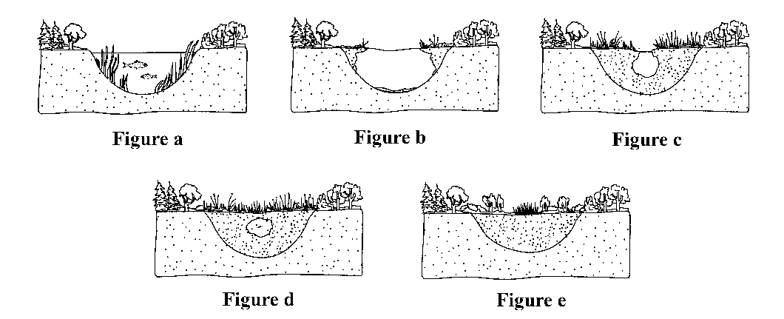

**6.** Which of these statements best summarizes the change in populations which has occurred during the stages of succession illustrated above?

**A** Populations of freshwater fish and aquatic plants are gradually replaced by populations of weeds and grasses as a

pond fills with silt.

**B** A terrestrial ecosystem is replaced by a freshwater ecosystem.

**C** A marine ecosystem is replaced by a terrestrial ecosystem.

**D** Populations of freshwater fish and aquatic plants die off as their habit becomes filled with silt.

**7.** Cowbirds do not build their own nests, but rather they lay their eggs in the nests of other birds. When the eggs hatch, the cowbird young are then taken care of by the birds who built the nest, often at the expense of their own young. This relationship is an example of

**A** parasitism **B** mutualism **C** predation **D** commensalism

|  |  |  |  |  |
| --- | --- | --- | --- | --- |
| Organism | Root  Adaptation | Stem  Adaptation | Leaf  Adaptation | Reproductive  Adaptation |
| **A** Water lily | Roots and root hairs absent | Stems bend with water flow | Stoma restricted to upper surface of leaves | Seeds can float |
| **B** Bromeliad | Aerial roots to absorb from the air | Smooth stems and leaves with drip tips allow water to runoff | Large, broad leaves | Animal pollinated |
| **C** Sagebrush | 3 sets of roots to collect water | Stems store water | Leaf hairs direct sunlight away from leaf surface | Seeds germinate in response to rain |
| **D** Fescue | Extensive roots survive fire and grazing animals | Soft stems bend in the wind | Narrow leaves prevent dessication | Wind pollinated |

**8.** Based on the adaptations listed in the table above, which organism is best suited for life in the desert ecosystem?

A. Water lily B. Bromeliad C. Sagebrush D. Fescue

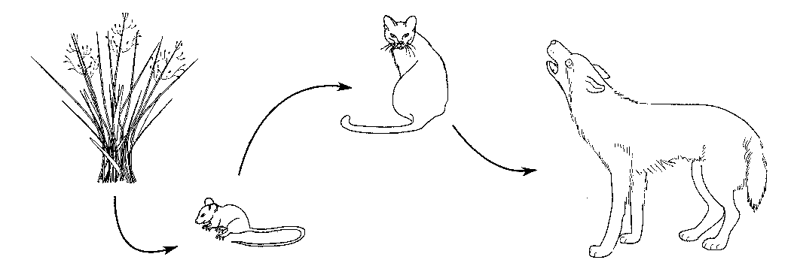

**9.** In an ecosystem, the simple food chain above shows the movement of matter and energy from one organism to the next. If disease reduced the number of organisms at the producer level, which other organism would feel the greatest effect?

**A** the mouse because it is a producer **B** the mouse because it eats producers

**C** the cat since it is a 2nd order consumer **D** the coyote because it is the top consumer in the food chain

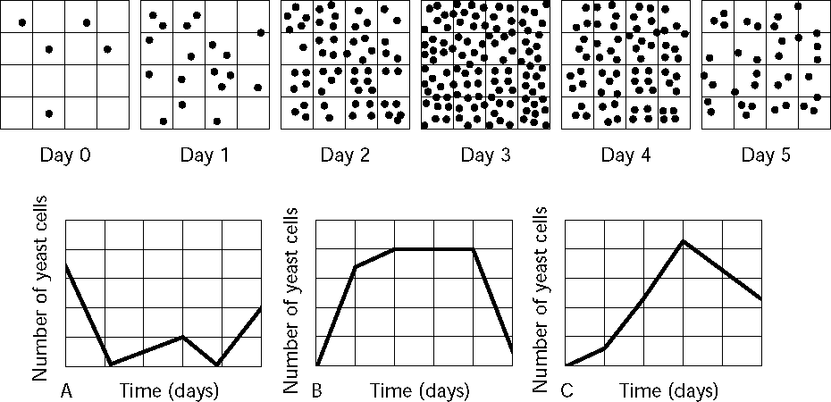

**10.** The graph depicts the growth of a population of yeast cells over time. The horizontal line most likely represents

**A** the limit of tolerance of the yeast cells to environmental conditions

**B** the highest number of yeast cells the population can achieve

**C** the carrying capacity of the environment

**C** population size of a predator which preys on the yeast

**11.** Throughout the decade of the 1930’s, a series of severe dust storms blew across the prairie lands of the United States, causing extreme ecological and agricultural damage. Years of poor farming practices and drought resulted in the loss of tons of topsoil to prevailing winds. Millions of acres of land became barren and uninhabitable. Loss of habitat due to the 1930’s dustbowl would likely lead to any of the following EXCEPT

**A** reduced access to resources

**B** increased competition between and among species

**C** population losses

**D** increased community complexity

**12.** How might clearing forest areas for the construction of factories potentially affect the stability of the carbon cycle?

**A.** A greater amount of O2 will be released into the atmosphere by the construction of factories while a decreased amount of

CO2 is produced by the remaining forest areas.

**B.** A lesser amount of CO2 will be taken in and used for food production by forests while more CO2 is produced by factories.

**C.** The amount of CO2 available for photosynthesis in the remaining forest areas will be decreased due to the construction of

factories.

**D.** The amount of O2 in the atmosphere available for animal respiration will likely increase due to deforestation.